**SQL QUERY SOLUTIONS**

1. select cm.CUSTOMER_NUMBER, cm.FIRSTNAME, am.ACCOUNT_NUMBER FROM customer_master cm JOIN account_master am ON cm.CUSTOMER_NUMBER = am.customer_number WHERE am.account_status = 'Terminated' GROUP BY cm.FIRSTNAME ORDER BY CUSTOMER_NUMBER;

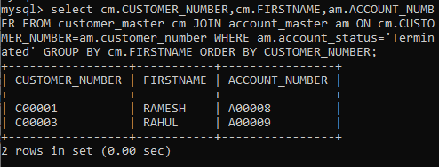

1. select b.branch_city,count(am.account_number)AS No_of_Accounts FROM account_master am JOIN branch_master b ON am.branch_id = b.branch_id GROUP BY branch_city;

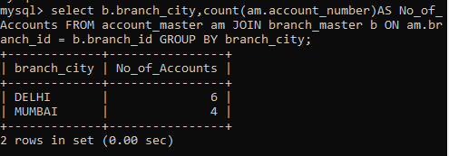

1. select cm.CUSTOMER_NUMBER, cm.FIRSTNAME, cm.lastname FROM customer_master cm JOIN loan_details l ON cm.CUSTOMER_NUMBER = l.customer_number GROUP BY CUSTOMER_NUMBER;

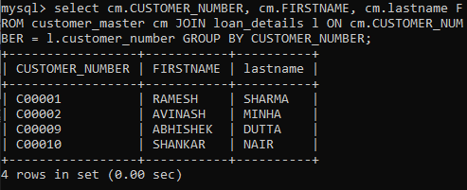

1. select count(l.customer_number) AS Count FROM loan_details l JOIN account_master am ON l.customer_number = am.customer_number WHERE am.account_status = 'TERMINATED' OR 'SUSPENDED';

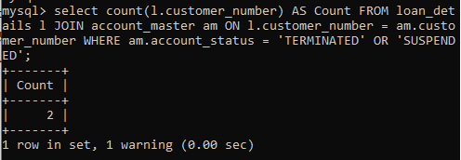

1. select cm.firstname , cm.CUSTOMER_CITY, am.ACCOUNT_NUMBER FROM customer_master cm JOIN account_master am ON cm.CUSTOMER_NUMBER = am.customer_number WHERE cm.occupation != 'SERVICE' OR 'STUDENT' GROUP BY firstname ORDER BY account_number;

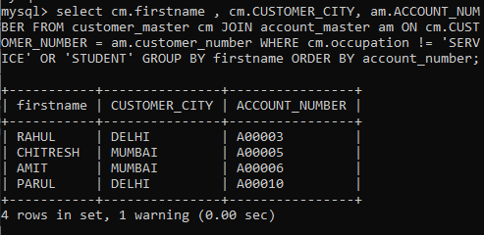

**JAVASCRIPT, HTML and CSS**

1. Write a Java Script to find the n prime number.

<html>

<head>

<script>

function getPrime(ele){

var ele = document.getElementById("lo").value;

var primes=[];

for (var i=1;i<ele;i++){

var prime=true;

var rootI=Math.sqrt(i)+1;

for (var j=2;j<rootI;j++){

if (i%j==0) {

prime=false;

break;}

};

if (prime) primes.push(i);

}

document.write(primes.join(' '));

}

</script>

</head>

<body>

<input type="text" id = "lo"/>

<button value="add" onclick="getPrime()">GET</button>

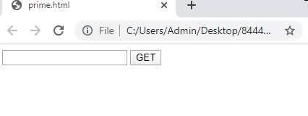

Output:

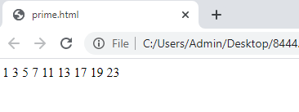

MODULE 1

1. (a) Create a html web page that contains a button with which it is possible to change the text that is shown on the screen. The file ButtonDemo.html has a JavaScript function named change_text() which is called after the button is pressed. When the button is pressed repeatedly the text changes Hello! ... Well done! ... Hello! ... Well done! ... Hello! ..  
   (b). Create a newHTML-document with an unordered list element, a text-box,and a button that says “Add.”

<html>

<head>

<script>

function changeText() {

var b = document.getElementById("this");

b.innerHTML = "Well Done!!";

}

function createlist(){

var b = document.createElement("li");

var ele = document.getElementById("lo").value;

var txt=document.createTextNode(ele);

b.appendChild(txt);

document.body.appendChild(b);

}

function removelist(){

}

</script>

</head>

<body>

<h1 id="this">Hello!!</h1>

<button value="change" onclick="changeText()">CLICK HERE</button><br>

<input type="text" id = "lo"/>

<button value="add" onclick="createlist()">ADD</button>

<button value="remove" onclick="removelist()">REMOVE</button>

</html>

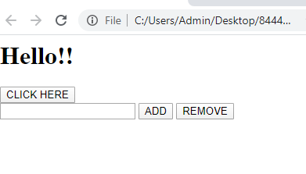

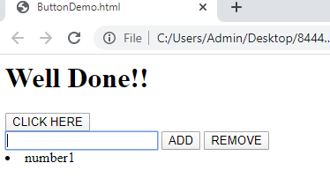

1. Using CSS properties create a calendar with following Calender Template:

<!DOCTYPE html>

<html>

<head>

<style>

* {box-sizing: border-box;}

ul {list-style-type: none;}

body {font-family: Verdana, sans-serif;}

.month {

padding: 50px 25px;

width: 100%;

background: tomato;

text-align: center;

}

.month ul {

margin: 1

padding: 0;

}

.month ul li {

color: white;

font-size: 30px;

text-transform: uppercase;

letter-spacing: 3px;

}

.month .prev {

float: left;

padding-top: 10px;

}

.month .next {

float: right;

padding-top: 10px;

}

.weekdays {

margin: 0;

padding: 10px 0;

background-color:grey;

}

.weekdays li {

display: inline-block;

width: 13%;

color: green;

text-align: center;

}

.days {

padding: 10px 0;

background: ;

margin: 0;

}

.days li {

list-style-type: none;

display: inline-block;

width: 13.6%;

text-align: center;

margin-bottom: 5px;

font-size:12px;

color: green;

}

.days li .active {

padding: 5px;

background:#1abc9c;

color: white !important

}

</style>

</head>

<body>

<h1>CSS Calendar</h1>

<div class="month">

<ul>

<li>

August<br>

<span style="font-size:18px">2017</span>

</li>

</ul>

</div>

<ul class="weekdays">

<li>Mo</li>

<li>Tu</li>

<li>We</li>

<li>Th</li>

<li>Fr</li>

<li>Sa</li>

<li>Su</li>

</ul>

<ul class="days">

<li>1</li>

<li>2</li>

<li>3</li>

<li>4</li>

<li>5</li>

<li>6</li>

<li>7</li>

<li>8</li>

<li>9</li>

<li>10</li>

<li>11</li>

<li>12</li>

<li>13</li>

<li>14</li>

<li><span class="active">15</span></li>

<li>16</li>

<li>17</li>

<li>18</li>

<li>19</li>

<li>20</li>

<li>21</li>

<li>22</li>

<li>23</li>

<li>24</li>

<li>25</li>

<li>26</li>

<li>27</li>

<li>28</li>

<li>29</li>

<li>30</li>

<li>31</li>

</ul>

</body>

</html>

